**Be a Buddy**

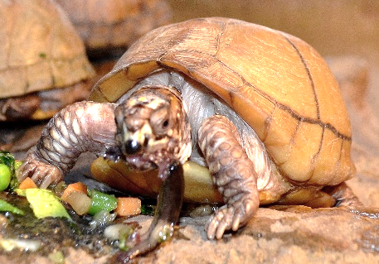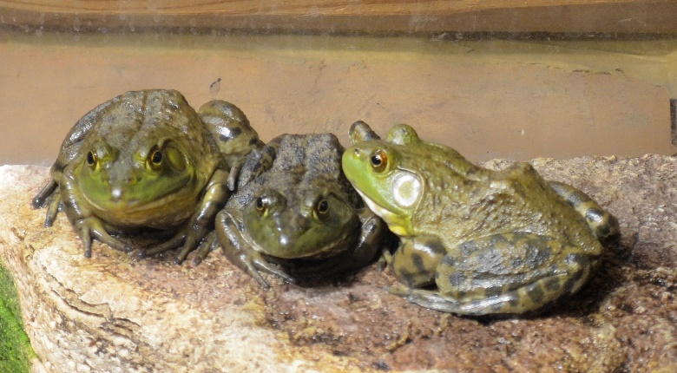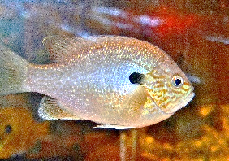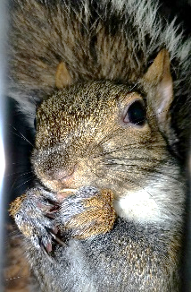

* **To a Box Turtle!**
* **To a Bullfrog!**
* **To a Bluegill!**
* **To a squirrel!**

The Grove

National Historic Landmark

Glenview Park district

Glenview, Illinois

**“Be a Buddy” Animal Sponsorship Program --- Application Todays date _______________**

I would like to sponsor: **________________________________________________ ___________**

(type of animal**)** (how many)

***If your animal sponsorship is a GIFT;* please till out the name and address of that person here:**

**Name ____________________________________________**

**Address ____________________________________________City/state/Zip ______________________**

**Choose one;  send the sponsorship package to the address above  send it to my address**

**Your name _________________________________________________________________**

**Your address ________________________________________________city/state/Zip _________________**

**Phone _______________________Email address: _____________________________________________**

Ask whether your employer has a **Matching Gift Program.** It can double your donation to The Grove.

We accept credit cards (no American Espress) , cash or check payment made out to The Grove.

The Grove National Historic Landmark

1421 Milwaukee Ave.

Glenview, IL. 60025

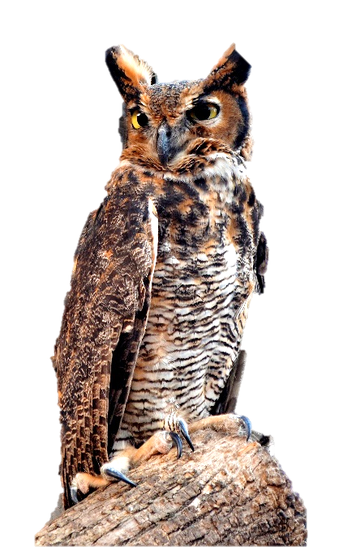

**A**

🙟 Would you like to help care for The Grove’s animals?

🙟 Are you looking for the perfect gift for the person who has everything?

🙟 Would you like to contribute to an excellent nature center like The Grove?

Then you may want to

**“Be a Buddy”**

And join The Grove’s

**Animal Sponsorship Program**

**“Be a Buddy” is perfect for:**

* Birthdays
* Anniversaries
* Holidays
* Earth Day
* School Groups
* Scout Troops

……and much more!

**You will receive:**

🙟 an official Certificate of Sponsorship,   
suitable for framing.

🙟 a color print of your animal.

🙟 a fact sheet about your animal..

🙟 a reminder one month before your sponsorship period ends.  
We encourage you to come and visit your animal, however, sometimes our animals may be temporarily loaned to schools or other nature centers.

**Animals for Sponsorship and Fees\***

**Snakes**

Northern Water Snake $20

Diamondback Water Snakes $20

Corn Snake $30

Black Rat Snake $30

Fox Snake $30

Speckled King Snake $30

Prairie King Snake $30

California King Snake $30

Bull Snake $35

Great Plains Rat Snake $30

Western Hog nose $30

Milk Snake $25

Blue Racer $30

**Turtles**

Map turtle $15

Sinkpot turtle $15

Red – eared Slider $25

Painted turtle $25

Soft Shell turtle $25

Soft Shell turtle baby $20

Box turtle $30

**Turtles (contd)**

Common Snapper $30

Blandings Turtle $30

Alligator Snapper $50

Young Alligator Sanpper $25

Florida Red Belly $30

**Amphibians**

Green Tree frog $15

Leopard Frog $15

American toad $15

Bullfrog $20

Tiger salamander $25

Siren $25

**Fish**

Bluegill $15

Long nose gar $30

Short nose gar $30

Alligator gar $35

Largemouth Bass $25

**Birds**

American Kestrel $50

Great Horned Owl $100

**Other**

Legless Lizard $25

Opossum $100

Eastern grey Squirrel $100

Russian Tortoise $50

***\*All sponsorships subject to availability***

***All fees are shared sponsorships***

**How do I sponsor an Animal?**

Review the list of animals available to sponsor, fill out the “Application for Animal Sponsorship” form on the back of this brochure, and return it to;

The Grove

1421 Milwaukee Ave.

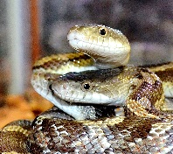Glenview, IL 60025

Your donation will help supply food and care for one year.

Please make checks payable to The Grove

